FORM INTERFACE AND GLOBAL DEFINITIONS

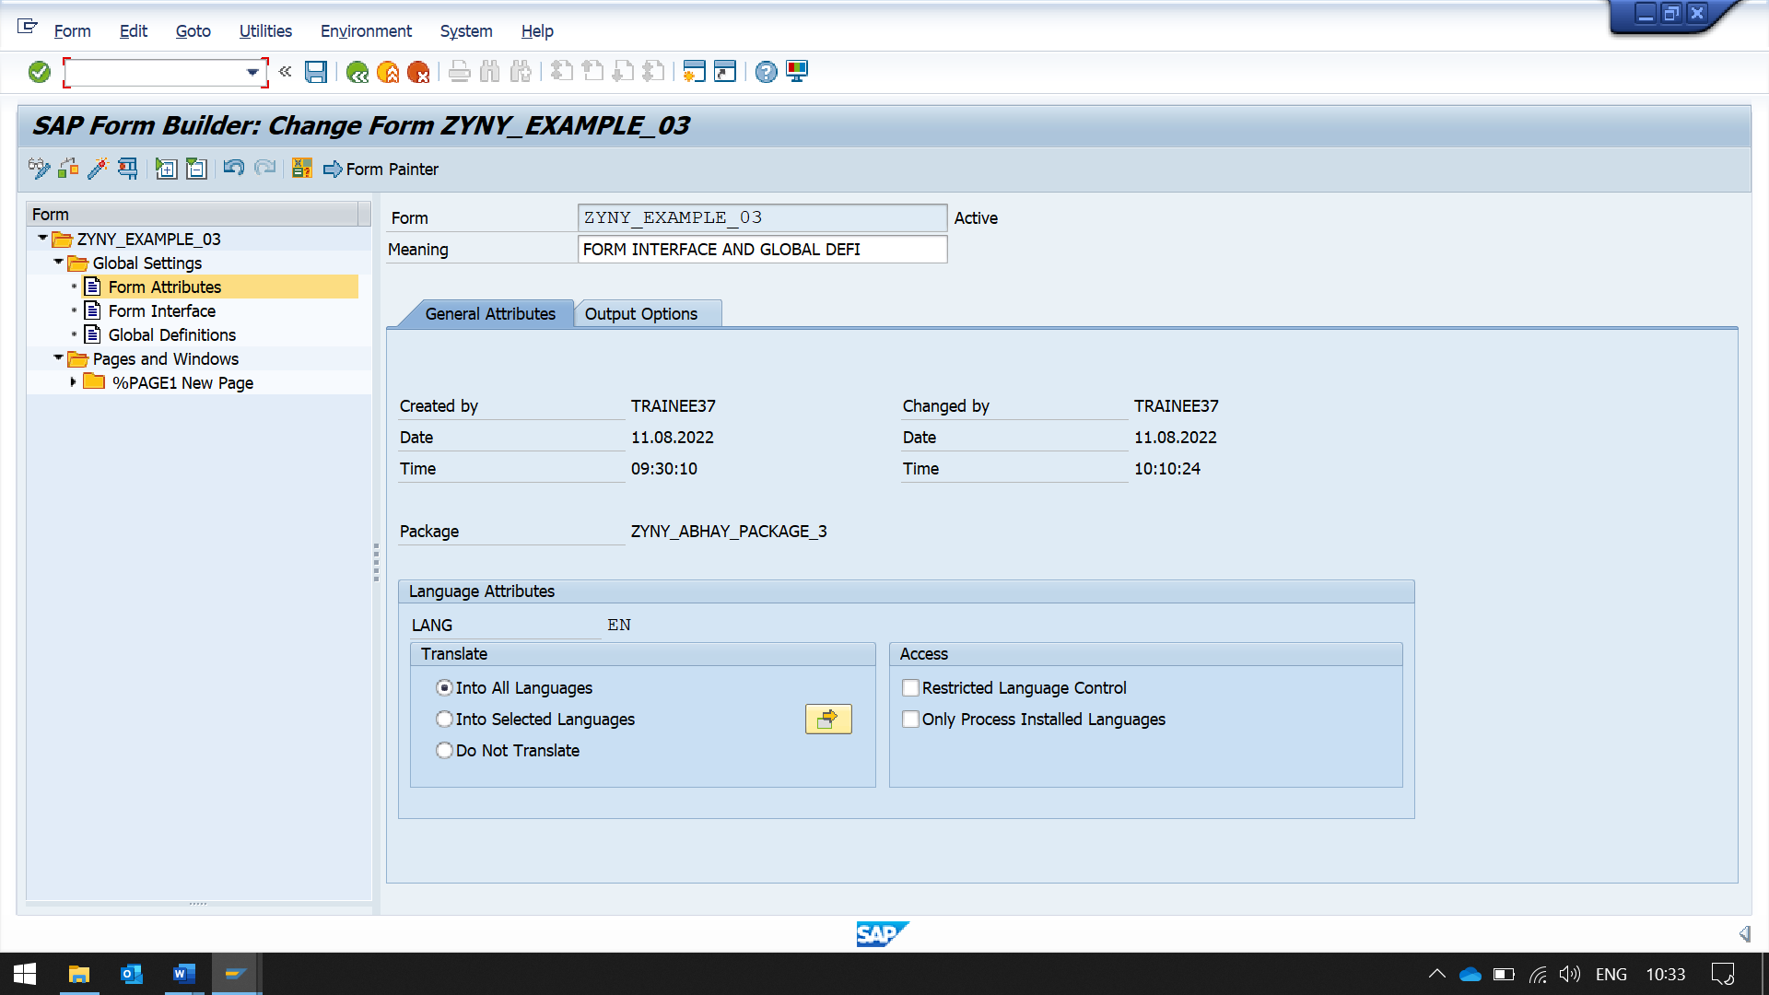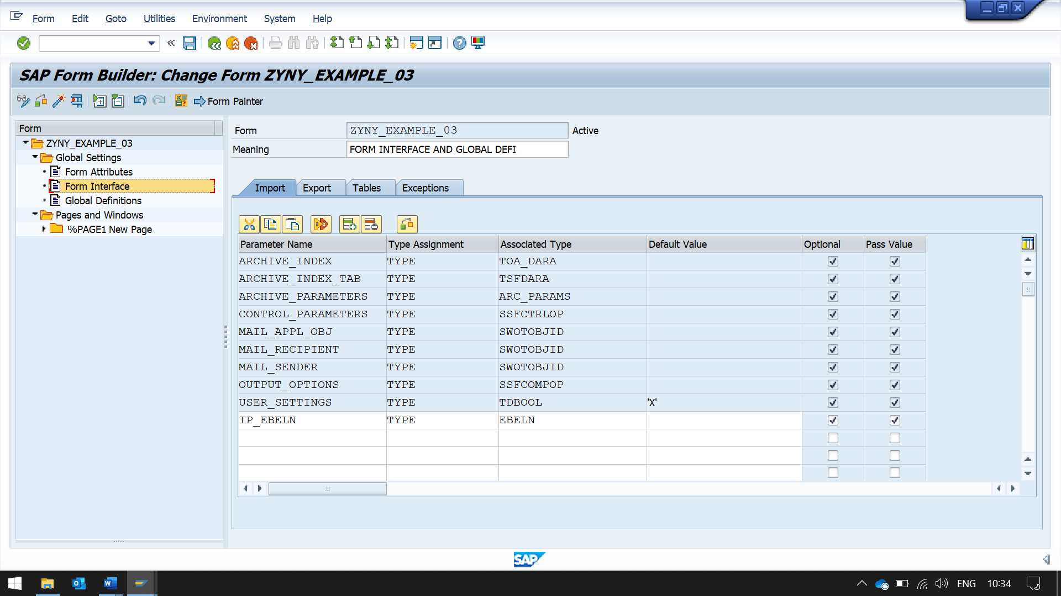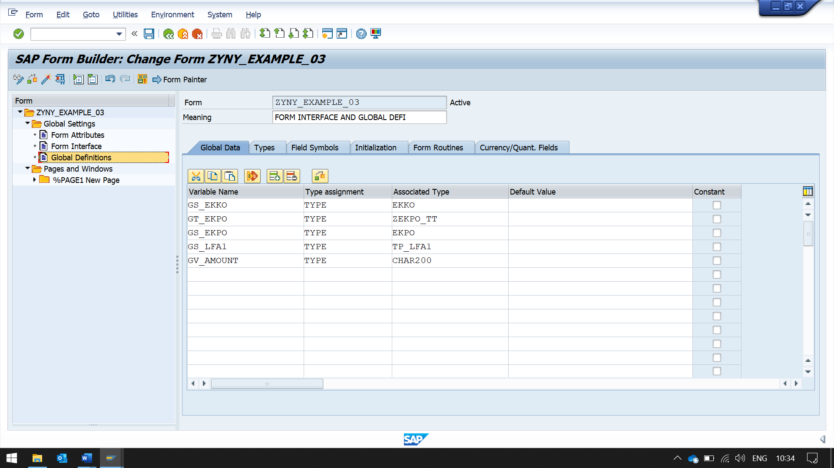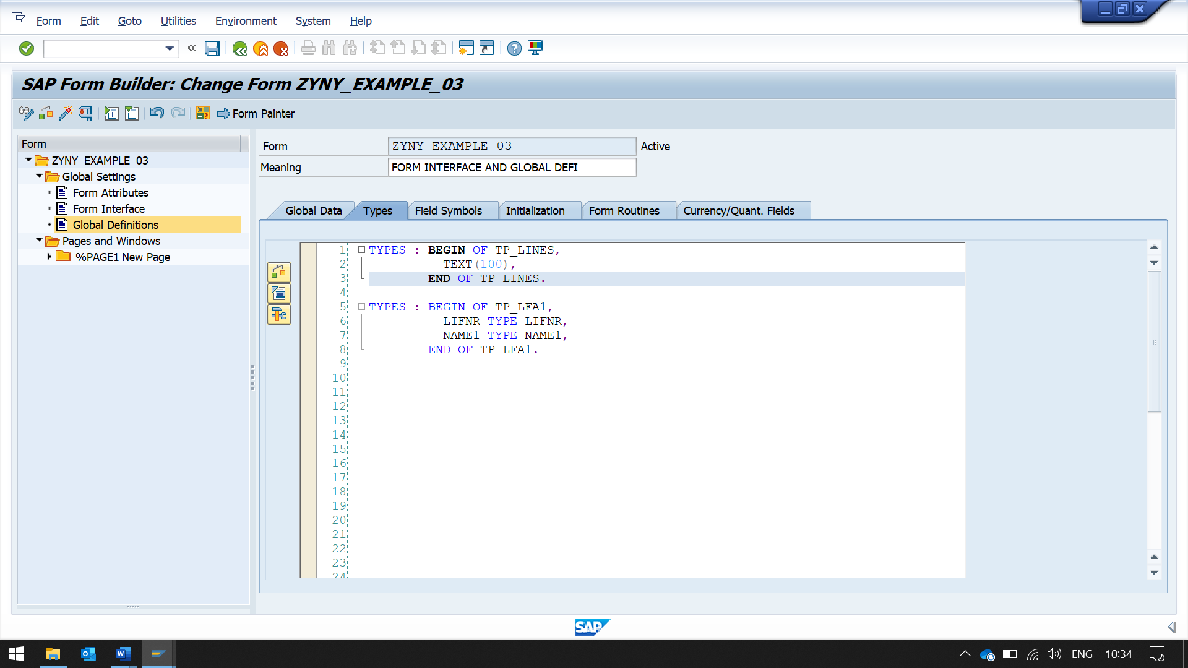 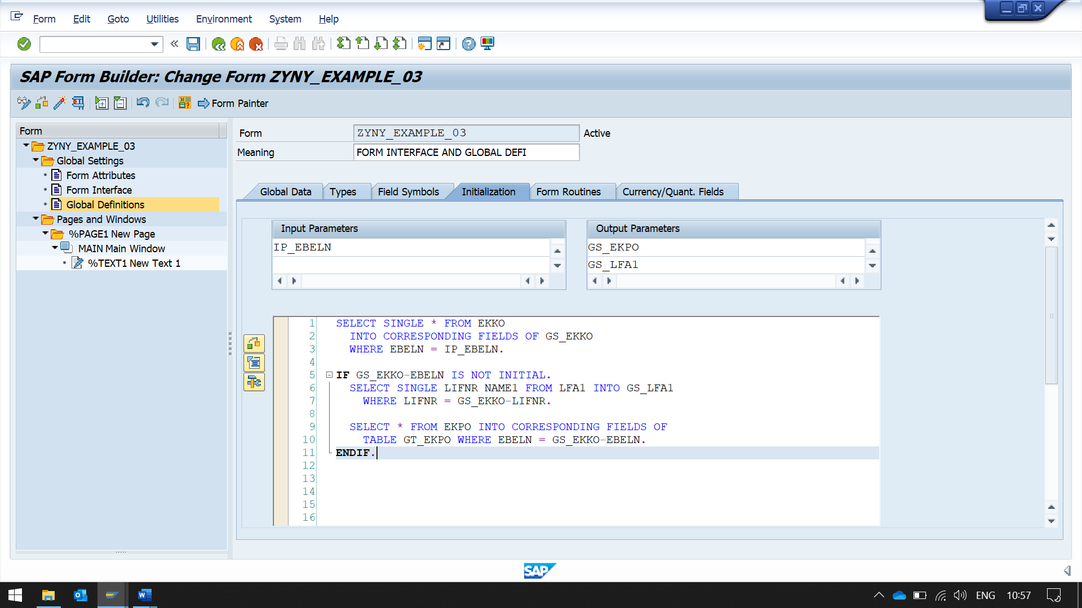

CAREFUL ABOUT PASSING THE OUTPUT PARAMETERS  
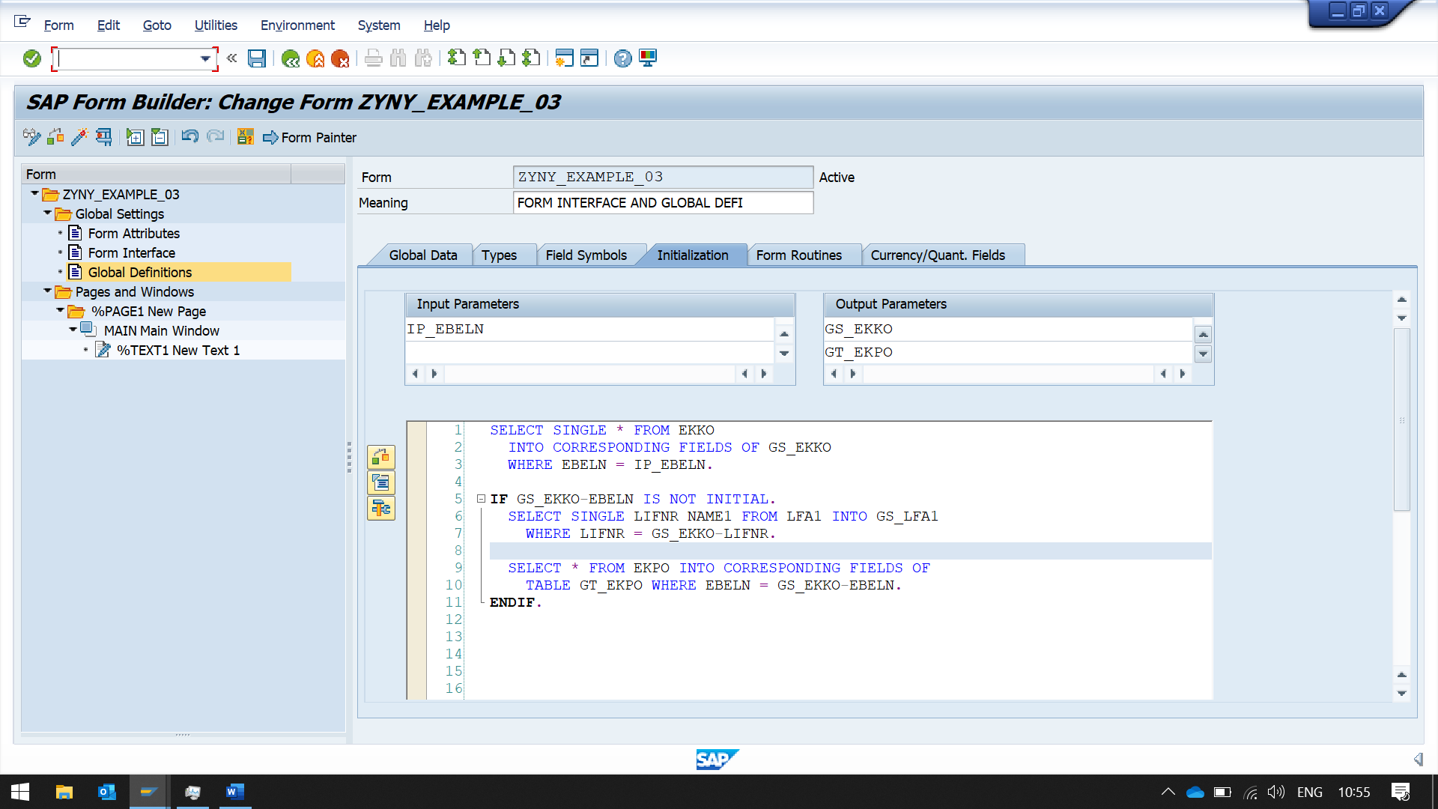

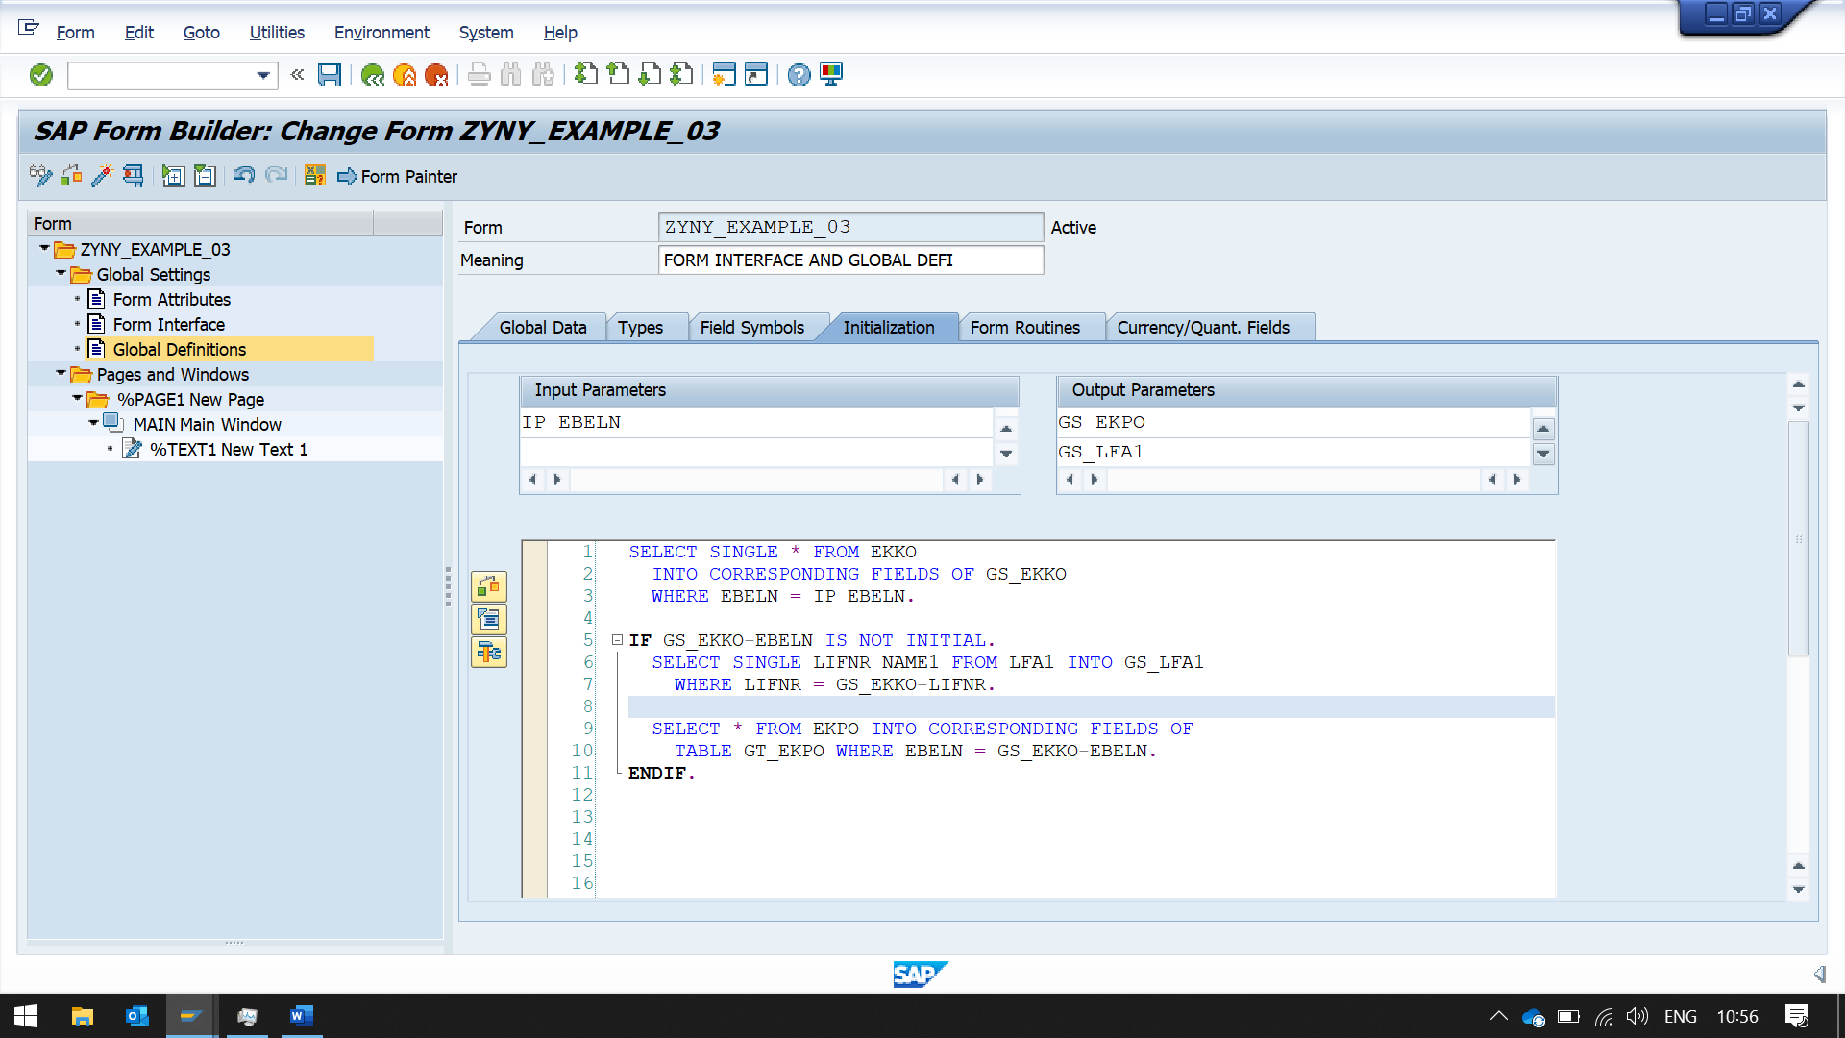

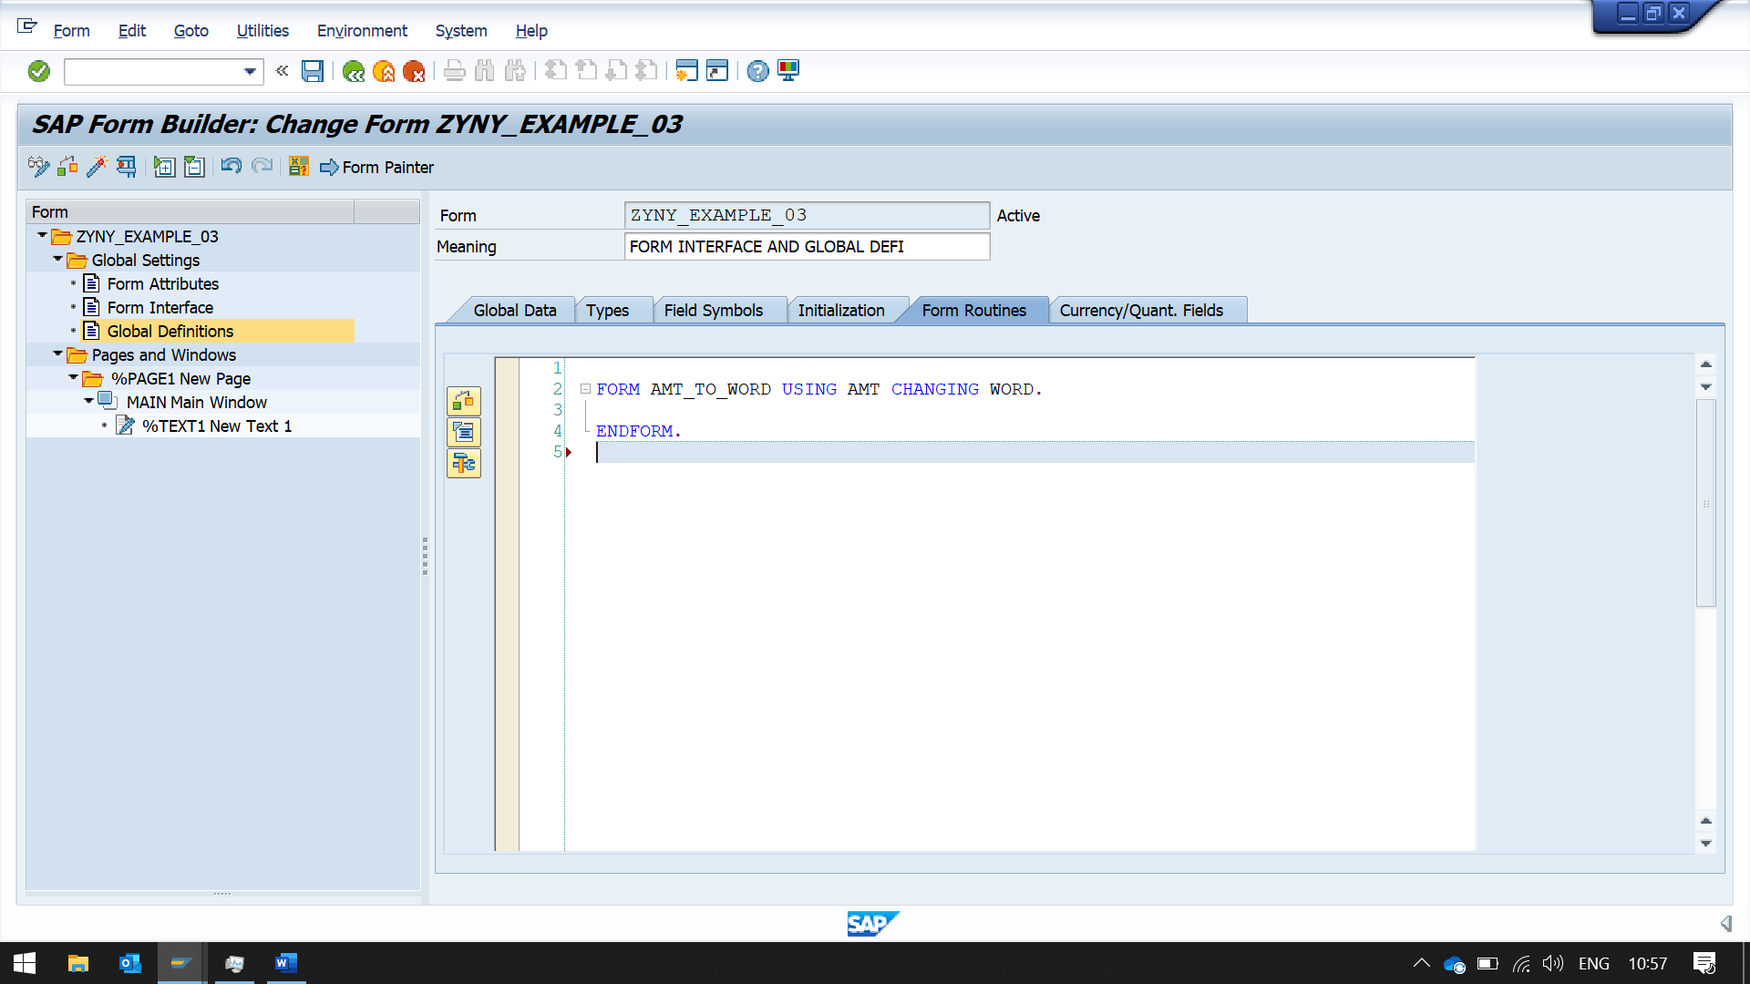TRIED FUNCTION ROUTINE, BUT THE SPECIFIC FUNCTION WAS NOT AVAILABLE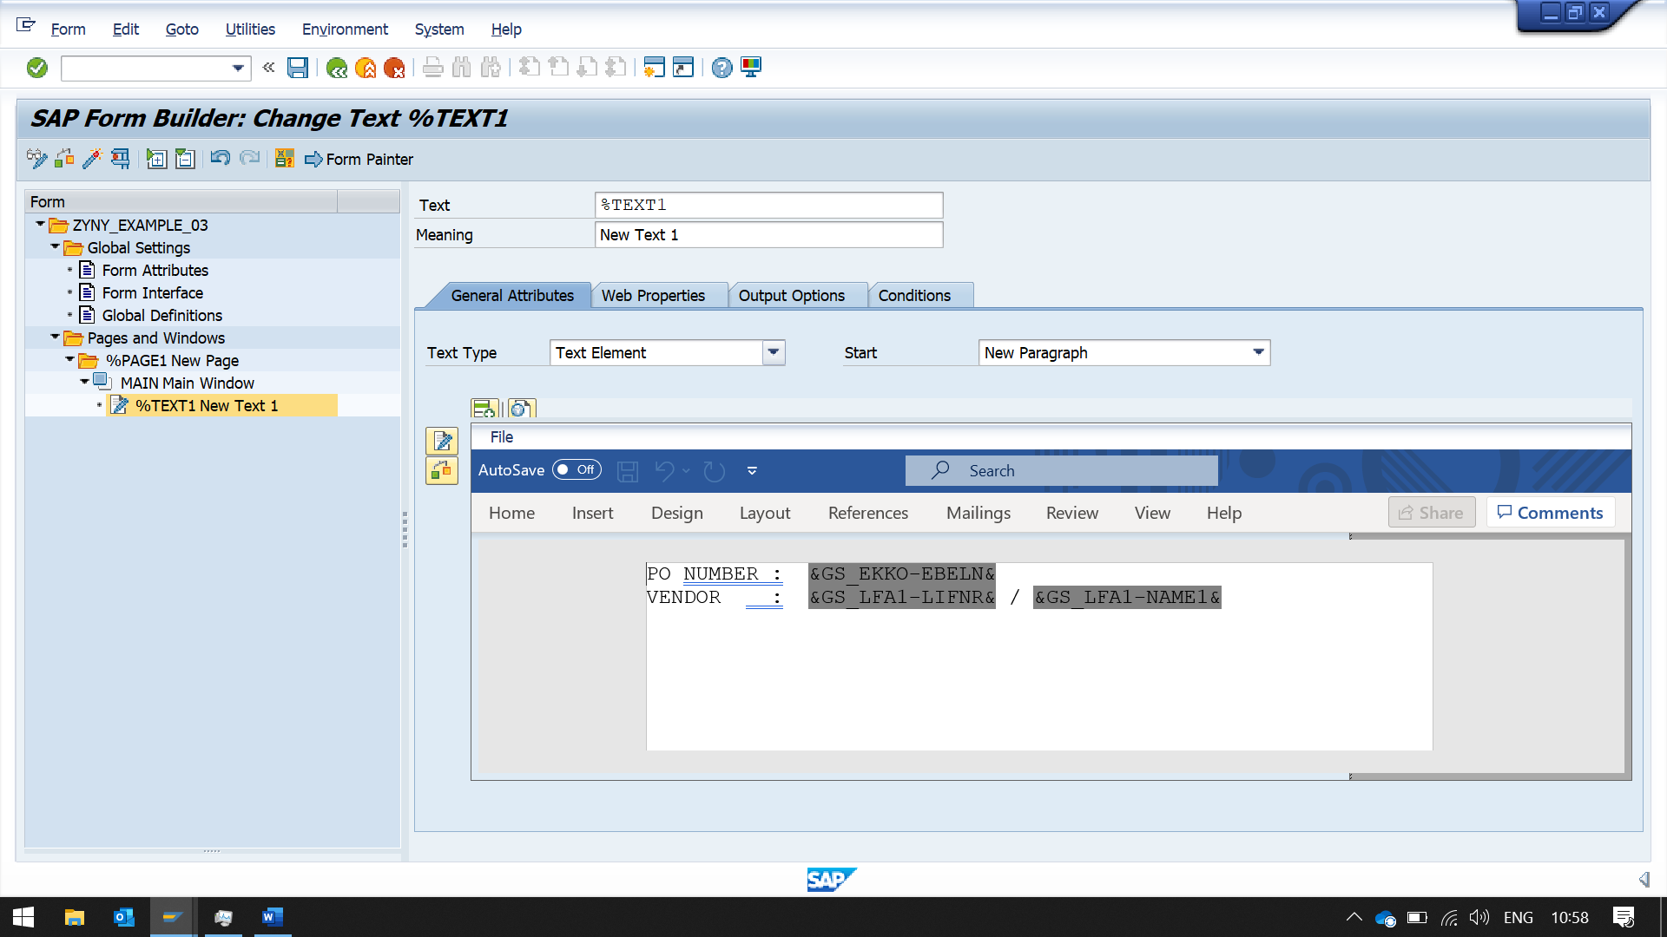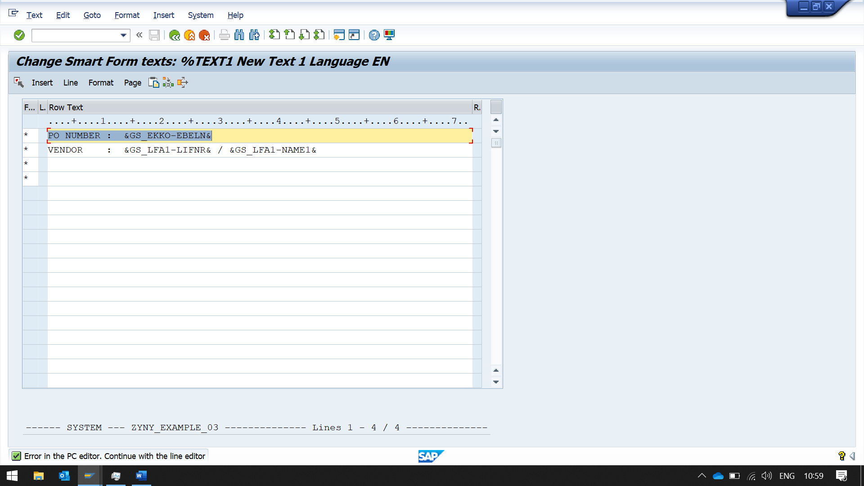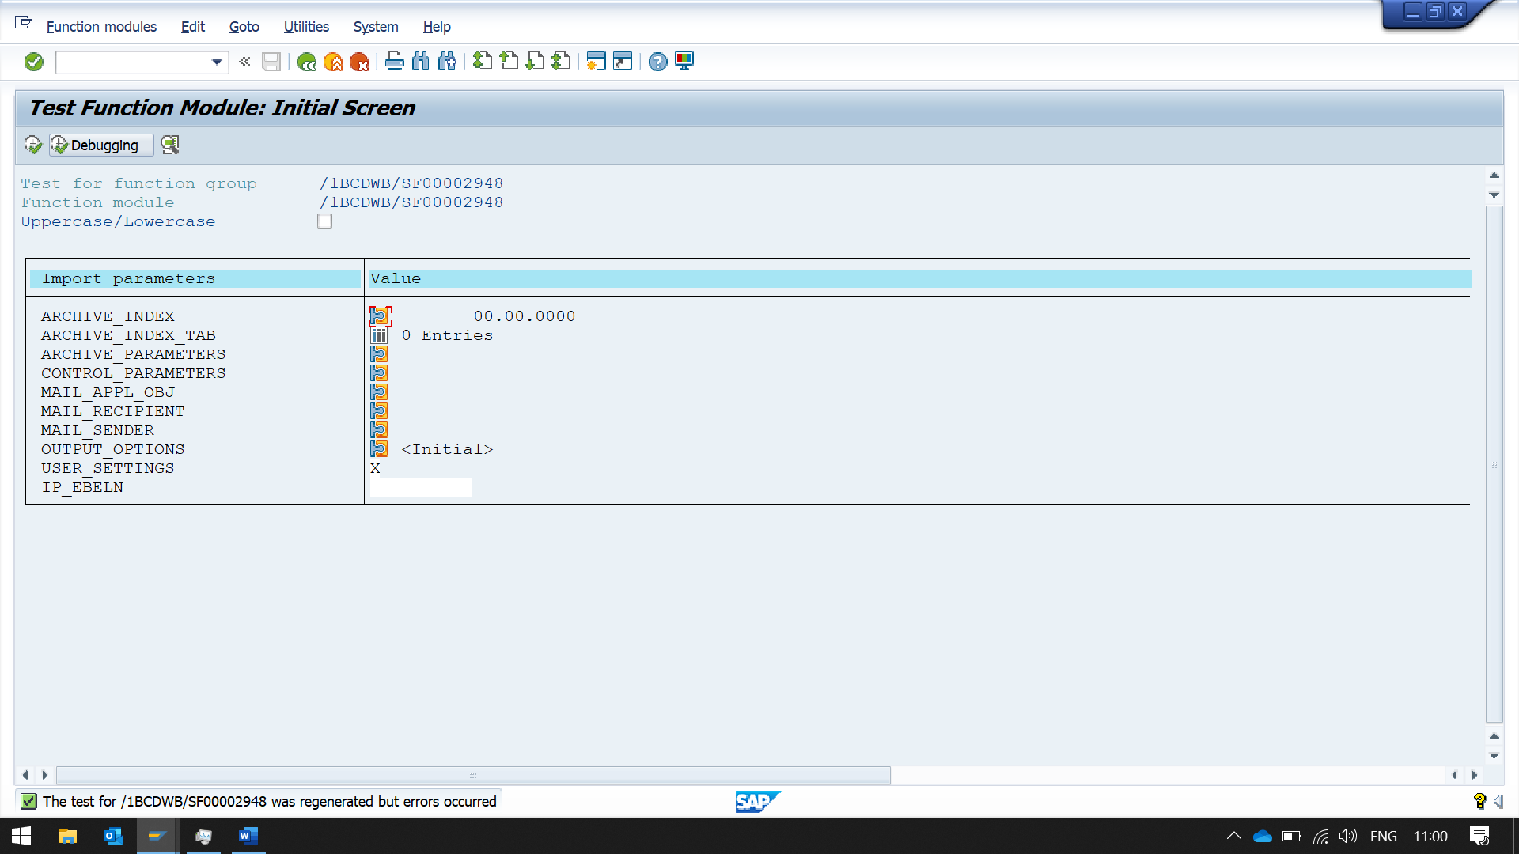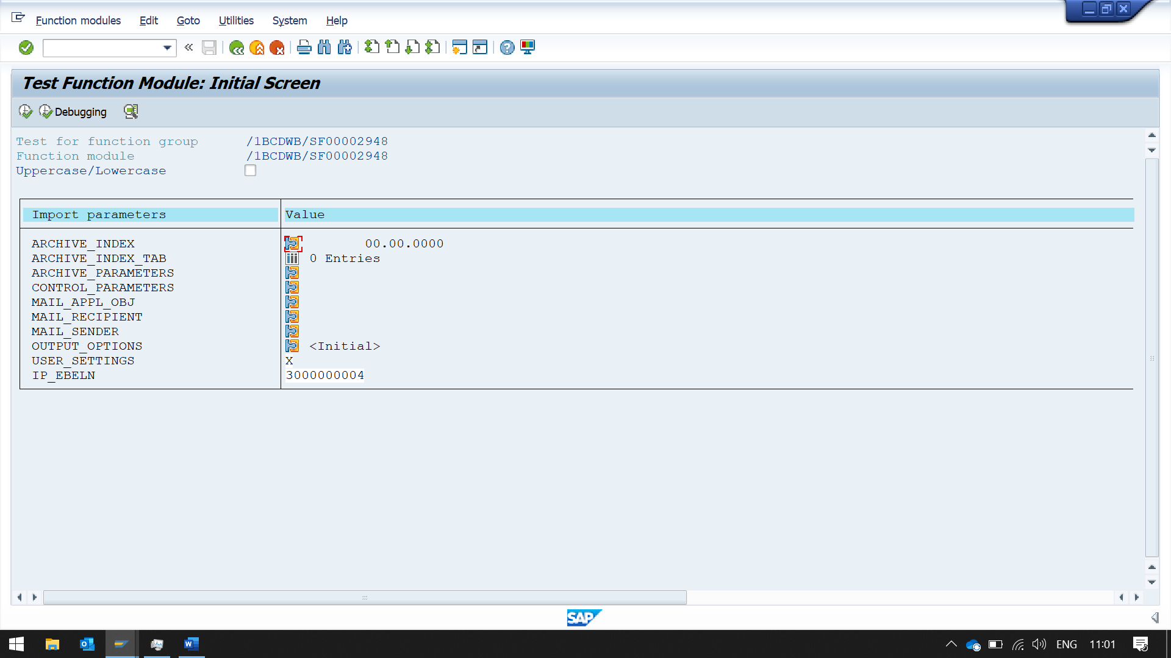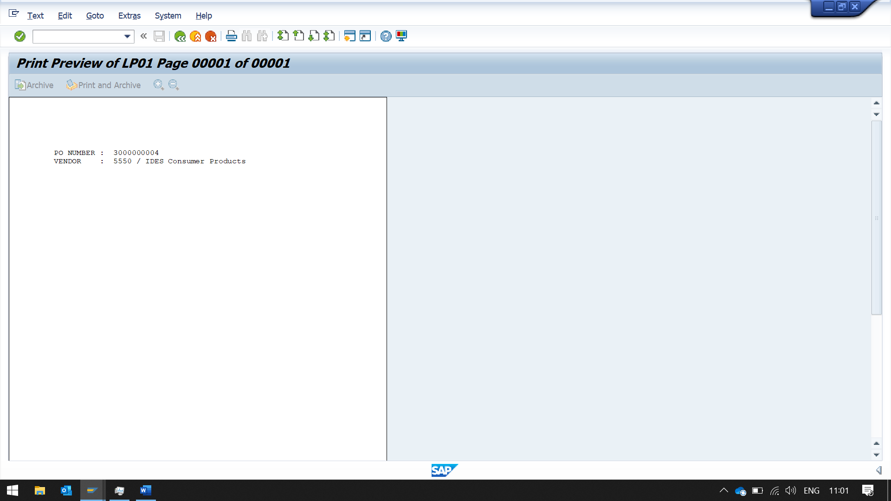

HERE IN THIS EXAMPLE

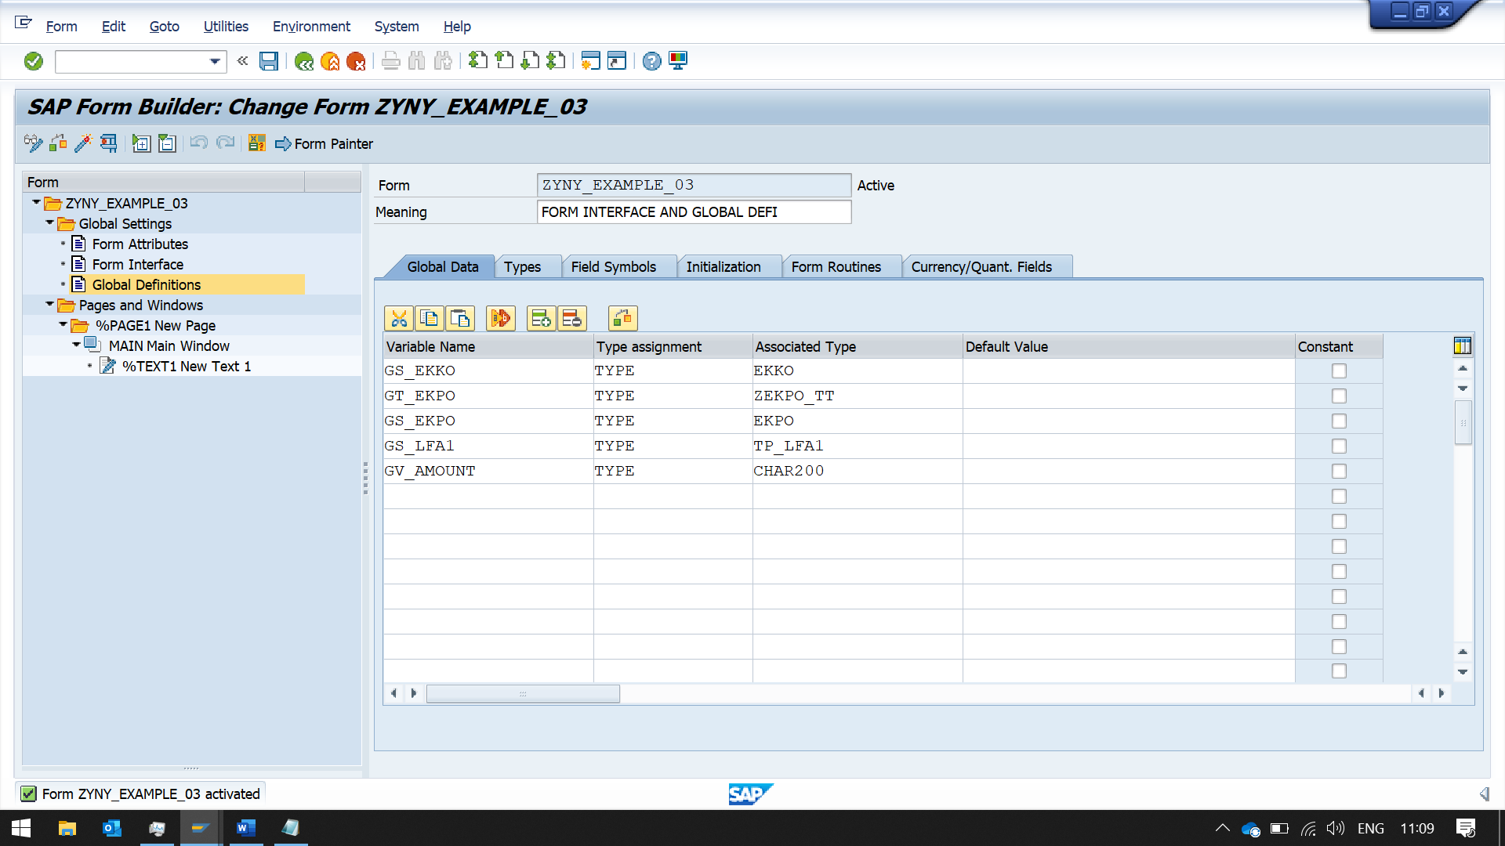

ZEKPO_TT TABLE TYPE IS CREATED FROM EKPO TABLE

BUT EVEN IF CREATING

TABLE -> STRUCTURE -> TABLE TYPE

IT WORKS

EKPO -> ZEKPO_STRUCT -> ZEKPO_TABLE_T

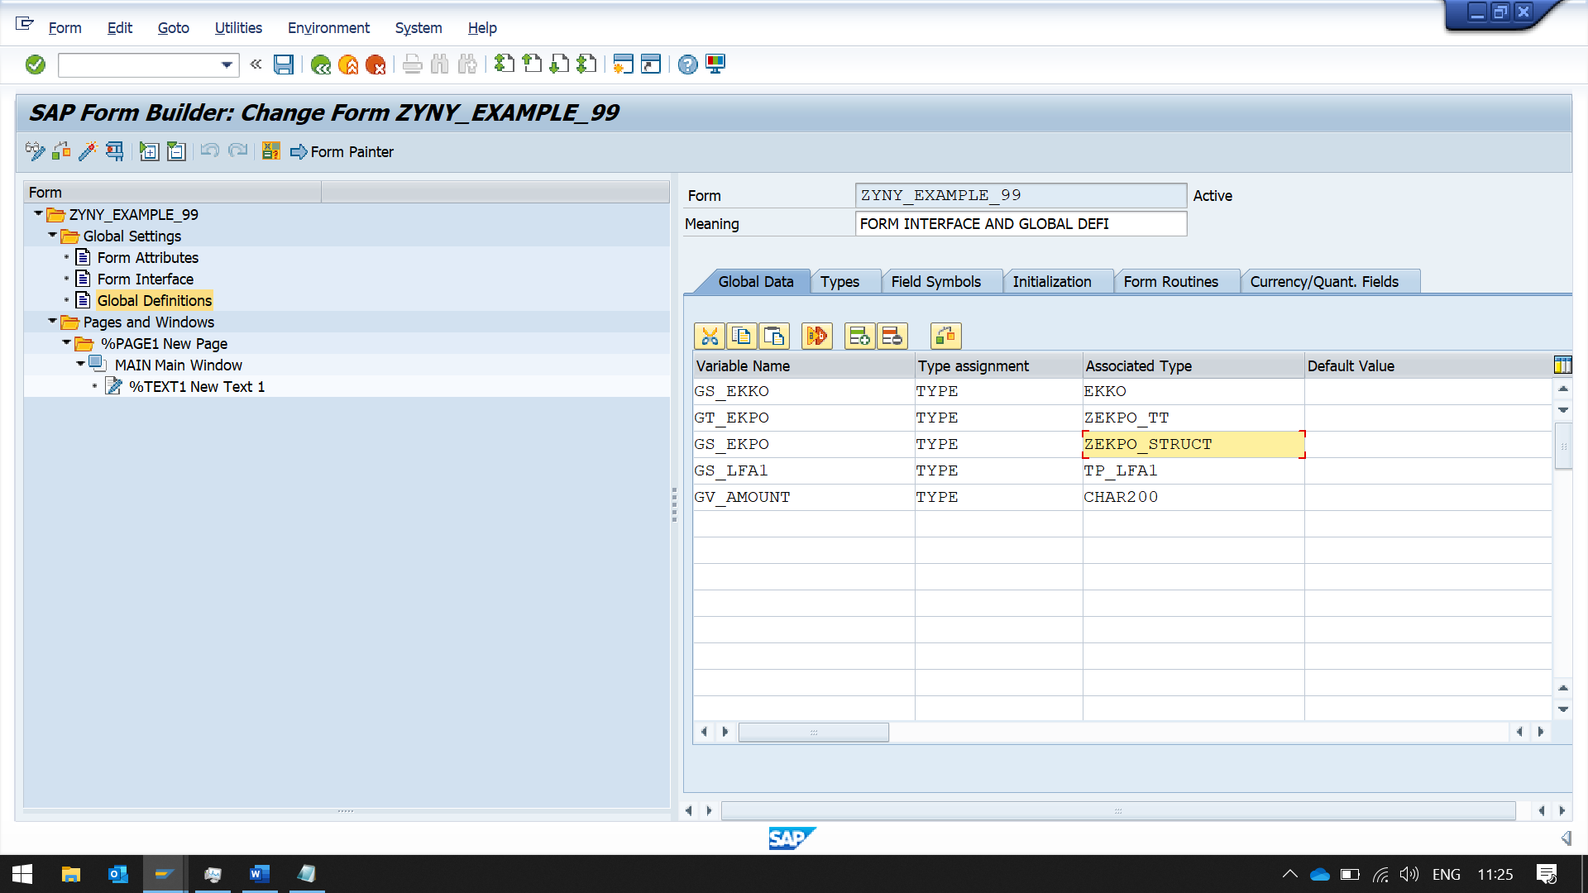NOW CHANGING WORK AREA REFERENCE FROM TABLE TO STRUCT

IT DOES NOT CAUSE AN ERROR